Bahria University,

Karachi Campus



LAB EXPERIMENT NO.

**10**

LIST OF TASKS

|  |  |
| --- | --- |
| TASK NO | OBJECTIVE |
| 1 | **Write a short note on Banker’s algorithm stating its main purpose and working mechanism.** |
| 2 | **Implement the Banker’s Algorithm explained above in C language.** |
|  |  |
|  |  |
|  |  |

Submitted On:

-June-2022

**Task No. 1: Write a short note on Banker’s algorithm stating its main purpose and working mechanism.**

**Solution:**

The Banker algorithm, sometimes referred to as the detection algorithm, is a [resource allocation](https://en.wikipedia.org/wiki/Resource_allocation) and [deadlock](https://en.wikipedia.org/wiki/Deadlock) avoidance [algorithm](https://en.wikipedia.org/wiki/Algorithm) developed by [Edger Dijkstra](https://en.wikipedia.org/wiki/Edsger_Dijkstra) that tests for safety by simulating the allocation of predetermined maximum possible amounts of all [resources](https://en.wikipedia.org/wiki/Resource_(computer_science)), and then makes an "s-state" check to test for possible deadlock conditions for all other pending activities, before deciding whether allocation should be allowed to continue.

**Task No. 2: Implement the Banker’s Algorithm explained above in C language.**

**Solution:**

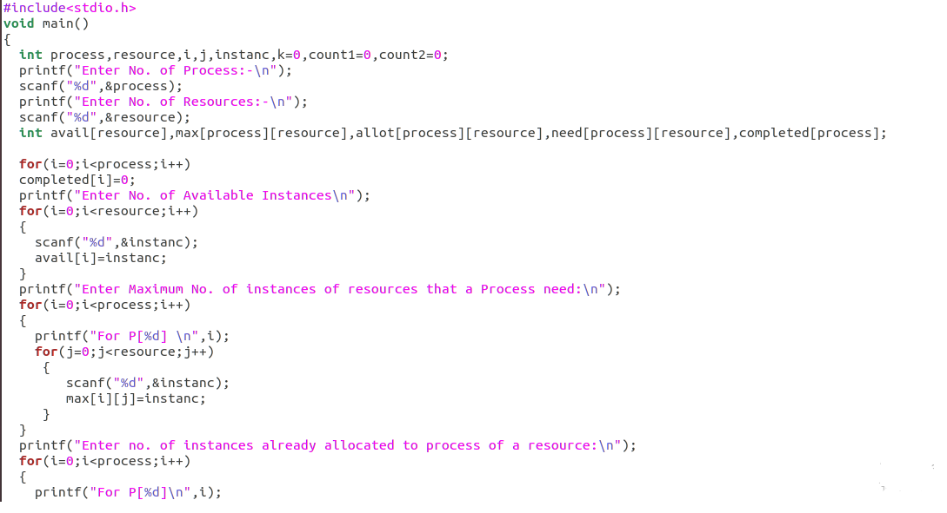

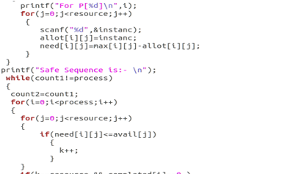

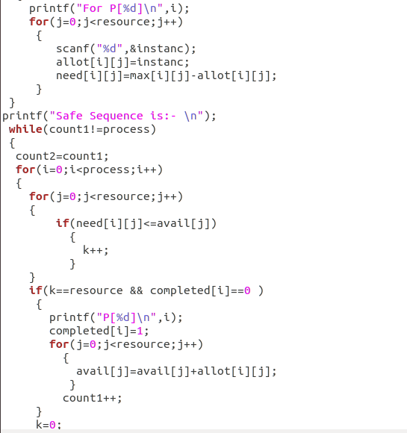

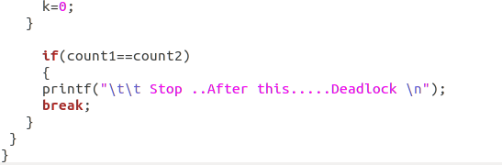

**Output:**

